Project Development Phase
Model Performance Test

Team ID | SWTID-2026-7816
Project Name | Auto Ticket Classification using Flow Designer
Maximum Marks | 10 Marks

Model Performance Testing:
Project team shall fill the following information in model performance testing template.
S.No. | Parameter | Values | Screenshot
 | Metrics | Regression Model:  MAE - N/A, MSE - N/A, RMSE - N/A, R2 score - N/A (rule-based keyword classification in Flow Designer; no regression model is used)  Classification Model:  Confusion Matrix - Network/Wi-Fi: 1 correct, 0 wrong; Hardware/Projector: 1 correct, 0 wrong (2 test tickets executed)  Accuray Score- 100% (2 of 2 tickets classified correctly)  Classification Report - Precision 1.00, Recall 1.00, F1-score 1.00 for the 2 classes tested (support = 1 each). Access and Performance rules were not covered by the executed tests. | 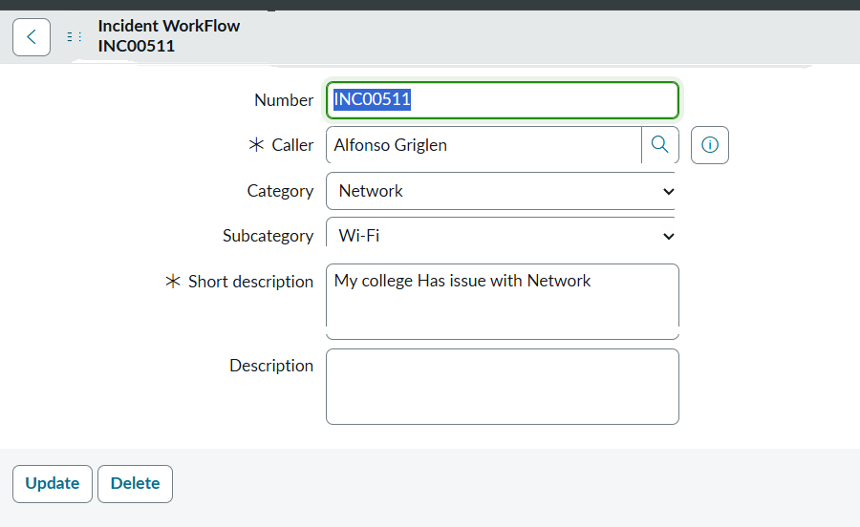  INC00511: Wi-Fi ticket auto-classified as Network / Wi-Fi  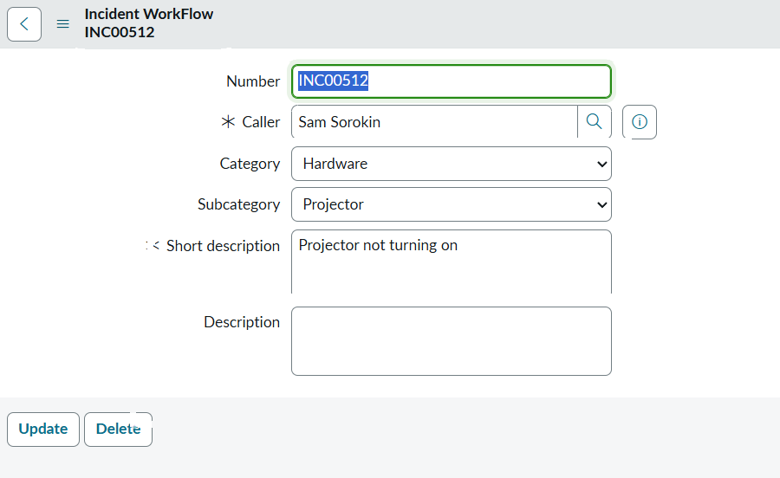  INC00512: Projector ticket auto-classified as Hardware / Projector  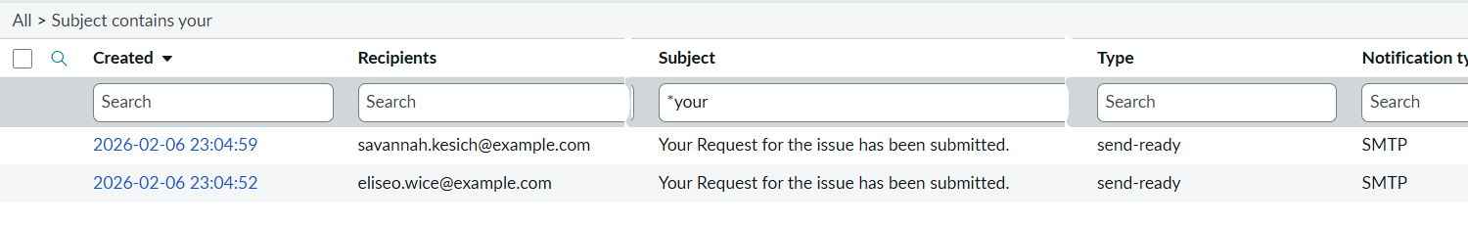  Emails log: confirmation email sent to caller  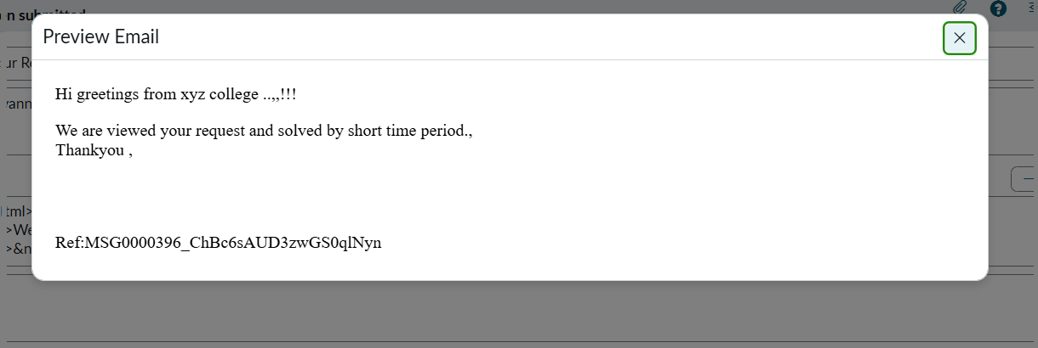  Preview of the confirmation email
 | Tune the Model | Hyperparameter Tuning - N/A (no trainable model). Accuracy is controlled by the keyword conditions in the Flow Designer If / Else If rules and the Category-to-Subcategory dependent values.  Validation Method - Manual test-ticket validation: create a ticket with Caller and Short Description, reload the form to check the auto-filled Category and Subcategory, then confirm the confirmation email in System Logs > Emails. | 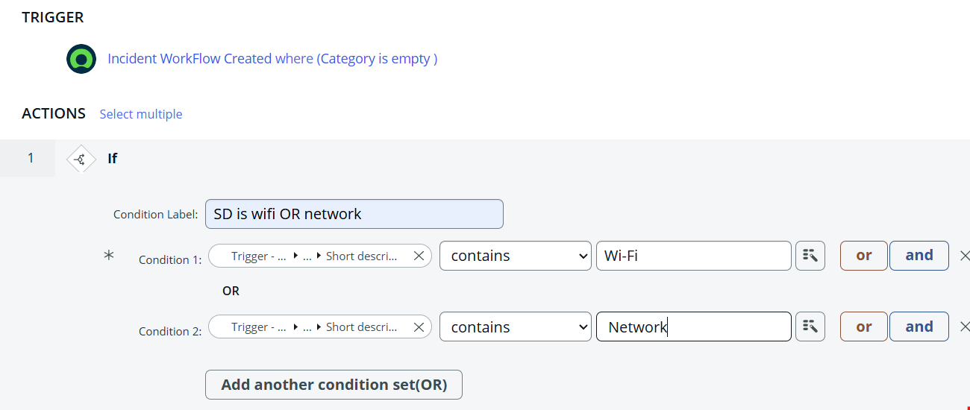  Flow Designer: keyword condition (Wi-Fi OR Network)  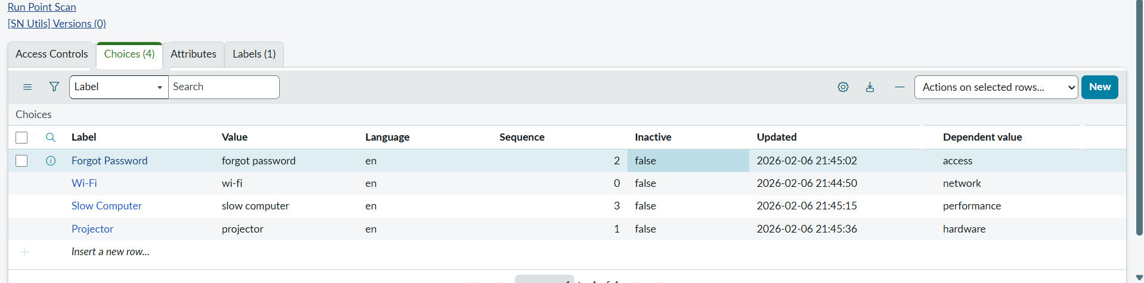  Subcategory dependent values mapped to Category

